# PE21 – Don't Die Part 1

This is a discovery maze game along the same lines of "Don't Starve".

The maze has the following structure, with the goal of starting at A and reaching H in as few moves as possible:

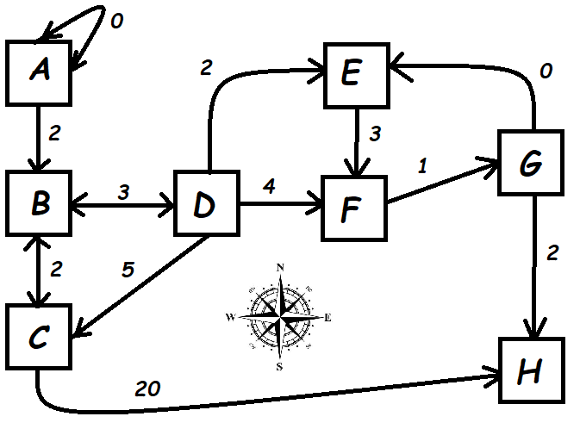

* Write the C# code to represent this digraph as both an Adjacency Matrix and as an Adjacency List. Note that you will have to represent the neighboring points, their relative direction, and their cost.
* In the game you will write in PE-22, each room has a maximum of 4 possible doors to the North, South, East and West. The cost of each edge between the rooms is the number of Health Points required to travel that edge. The player's HP will be reduced by the cost of the edge, and the player dies if their HP reaches 0. Therefore the player can only "see" the doors for which they have sufficient HP to access.

## Submission

Submit your GitHub URL to the corresponding MyCourses dropbox.